Can you Taste the Rainbow?

Do you have a good sense of smell and taste? Have you ever done a blind folded taste test? Well, you are about to! Let’s test your ability to taste without your eyes. Without your eyes, do you think it will be difficult to decipher the difference between each flavored skittles.
I may be harder than you think! You need all your senses to perceive the flavor of the skittles, accurately!
What you will need:
- 2 students grouped together
- 1 blindfold per group
- 1 nose clip or laundry pin per group (to pinch nose closed) – OR they can use fingers to pinch
- 20 Skittles (4 sets of each 5 colors), per group of 2 (if you choose to do both attempts, nose plugged and blindfolded)
- A copy of the following page, as a handout
What you will do:
- When each group is ready, you will talk to them about taste & smell (from the “How do you taste” sheet) and how they are related.
- First the groups will START with blindfolds and nose plugged, try to taste the rainbow of colors/flavors.
- NEXT, try it with only the blindfolds.
  - Is it easier/harder with only blindfolds?
  - Why?
Let’s get started:
- With your eyes blindfolded and nose plugged:
- Close your eyes and have your friend hand you each flavor of the skittles, one at a time.
- Taste it and guess what flavor/color it is. No Peeking or hints!
- Have your friend write down your answers vs the actual color given.
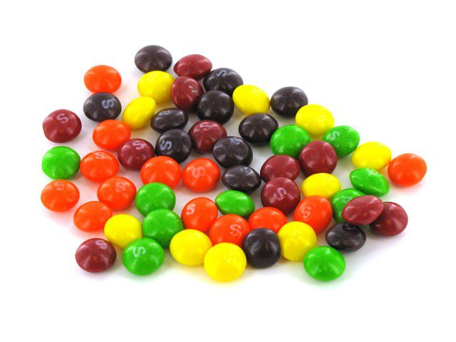
- Next, take off nose plug and try step 2-4 again!

Attempt 1 – Blindfolded with nose plugged (No eyes/nose)
Attempt 2 – Blindfolded (No eyes)

Can you taste the Rainbow?
**Feed samples randomly, not in color order**

Skittles
(In color order)

Describe the flavor.
What does it taste like?

Which was easier?
Did they get them right?

No eyes/nose No eyes
Comment without eyes:
Comment without eyes:
Comment without eyes:
Comment without eyes/nose:
Comment without eyes:
Comment without eyes/nose:
Comment without eyes:
Comment without eyes/nose:
Comment without eyes/nose:
Comment without eyes/nose:

