Raising Agents

Why do some recipes use leavening agents and how do they work?
What are chemical raising agents?
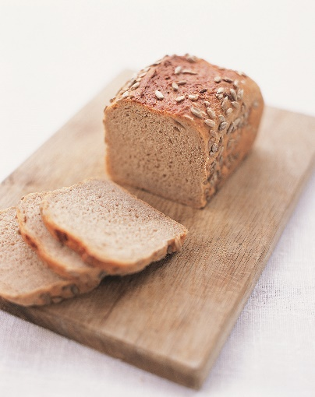
- A common chemical raising agent used in food is baking powder, which contains two active ingredients, baking soda (sodium bicarbonate - something called an alkali) and cream of tartar (potassium hydrogen tartrate - something called an acid).
- Baking soda can be used if the other ingredients contain an acid, such as buttermilk, lemon juice or vinegar.

How do chemical raising agents work?
- When the molecules of baking soda and cream of tartar come into contact in water, the alkali and acid begin to react together producing new molecules. One of which is the gas carbon dioxide.
- Gases tend to take up much more space than liquid or solid things such as water or ice, so when the gas is formed by the reaction of the baking powder in the water, little gas bubbles create pockets in the baking mixture, making foods like cakes and muffins light and fluffy.
- It is best to add baking powder to ingredients last, as it starts to react as soon as it comes into contact with water.

What is a biological raising agent?
- Yeast, a tiny single-celled microorganism, a type of fungus, is an example of a biological raising agent.
- Yeast is used to make bread dough.

How do biological raising agents work?
- Yeast feeds on the sugar contained with the dough, producing carbon dioxide and alcohol, in a process called fermentation. During bread making, the dough is left in a warm place. The warmth causes fermentation to take place. However if the temperature is too high, for example during the cooking process the yeast is killed.
- During fermentation, carbon dioxide is produced and trapped as tiny pockets of air within the dough. This causes it to rise. During baking the carbon dioxide expands and causes the bread to rise further.

Let’s Begin:

What you’ll need (per group):
- 4 clear plastic water bottles, labeled (for this amount of ingredients, we used 8 oz water bottle)
- 4 small balloons
- 3x, 15 ml (15 ml or 3 teaspoons) tap water
- 2, 10 g (10 g or 2 teaspoons) of bicarbonate of soda (Baking Soda)
- 10 g of baking powder
- 300 ml (or 1 ¼ cup) warm water
- 5 g vinegar (white distilled)
- 10 g (or 2 teaspoons) sugar
- 1g yeast (labeled baker’s yeast)
- Funnel (optional)

Directions:
- Add the dry ingredients to each of the balloons (using a funnel), set aside.
- Add water to each bottle as directed in below table.
- Stretch the small balloon over the neck of the plastic bottle (it may help to stretch the balloon once or twice beforehand).
- Once it has been sealed, add the powder from within the balloon to the water and shake the bottle gently.
- Repeat for each set of ingredients, 1-4 (below).
- For the yeast experiment (#4) keep in a warm place for an hour.
- You should see different volumes of gas collected in the balloon.

 | #1 | #2 | #3 | #4
Add to Balloon | Bicarbonate of soda (10g) | Baking powder (10g) | Bicarbonate of soda (10g) | N/A
Add to Bottle | Tap water  (3 tsp, or 15 ml) | Tap water  (3 tsp, or 15 ml) | Vinegar (1 tsp or 5ml) &  tap water (3 tsp, or 15 ml) | Yeast (1g), Sugar (10g) & 300 ml warm water

AQA video: https://www.youtube.com/watch?v=JvSmOGSKgnU
Source: https://www.ifst.org/lovefoodlovescience/resources/raising-agents-chemical
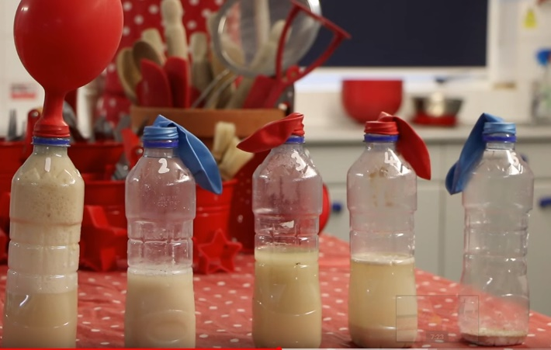
Talking points:
- Explain the air bubbles seen in baked goods comparing chemically leavened systems (typical in cakes) and yeasts (typical in breads). If it is possible, bringing in products for demonstrating can be more engaging.
- Discuss the common confusion for home bakers between baking soda and baking powder. Ask if anyone knows the difference or has made the mistake of switching them in a recipe (and if it caused any problems).
 | #1 | #2 | #3 | #4
Add to the Balloon | Bicarbonate of soda (10g) | Baking powder (10g) | Bicarbonate of soda (5g)
Add to the Bottle | Tap water (3 tsp) | Tap water (3 tsp) | Vinegar (5g) and  tap water (3 tsp) | Yeast (1g)  sugar (3g) and warm water (300ml)
Expected Outcome | No air formation | Quick swelling of balloon | Quick swelling of balloon | Slow swelling of balloon

- This mixture does not have an acid and thus the reaction does not take place. No CO₂ is formed.
- The baking powder contains both an acid and an alkali, and the swelling from the balloon is caused from the release of CO₂.
- Similar to #1 except this time we have added an acid (vinegar). The reaction takes place and the CO₂ fills the balloon.
- With warm water, the balloon should slowly fill with CO₂. Place the bottle somewhere warm (or in a bowl of warm water) where the attendees can watch for the duration of the experiment.

Notes to the organizer: the volumes and masses are approximate and can be modified based on the size bottles or availability of ingredients.

